TEMPLATE FOR AN ABSTRACT OF ICP2027 PORTO
Nuno Mateus¹, Victor de Freitas²
¹REQUIMTE/LAQV, Biochemistry Department, Faculty of Sciences, University of Porto, Portugal
²REQUIMTE/LAQV, Chemistry Department, Faculty of Sciences, University of Porto, Portugal
Contact e-mail: nbmateus@fc.up.pt

Abstract
The whole abstract must be written within one page without subtitles. It can be divided into several paragraphs, if needed, but one paragraph is fine as well.
The abstract should be a concise presentation of the background, methods and main results of your interesting polyphenol research. This main body of text can be max 2500 characters, including spaces. After that you can add max 1 figure or 1 table (in a separate box). At the end, you can have max two references (in a separate box). You are not supposed to add any other types of sections to your abstract, e.g. acknowledgements or funding sources are not included.
Your abstract will be used during the conference to attract people to your talk or to your poster session. After the conference this one-page abstract is published in the conference proceedings called Polyphenols Communications. This series will have a unique ISSN number that allows your publication to be cited like any other publication. Before the conference your abstract will be used by the Scientific Committee to evaluate whether you are accepted for an oral or poster presentation. In addition to the invited talks, we will give several slots for 15 min oral presentations (opportunities for both young and more experienced scientists) and some slots for short 3 min oral presentations of the selected poster presentations (in the main sessions).

Image/Table
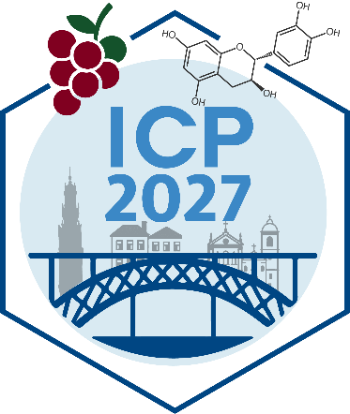

References
[1] Tao, W., et al. Food Chemistry, 520, 149787, 2026.
[2] Nunes da Silva, R., et al. Applied Food Research, 6(1),102060, 2026.

